SET-3

H.T No
Regulations:
A22

Sreenidhi Institute of Science and Technology
(An Autonomous Institution)
Code No: 9HC11 Date: 16-Mar-2023 (FN)

B.Tech I-Year I- Semester External Examination, March-2023 (Regular)
MATRIX ALGEBRA AND CALCULUS (ME, IT, ECM and DS)

Time: 3 Hours Max.Marks:60

Note: a) No additional answer sheets will be provided.
b) All sub-parts of a question must be answered at one place only, otherwise it will not be valued.
c) Missing data can be assumed suitably.
Bloom's Cognitive Levels of Learning (BCLL)

Remember | L1 | Apply | L3 | Evaluate | L5
Understand | L2 | Analyze | L4 | Create | L6

Part - A Max.Marks: 6x2=12

Answer all QUESTIONS, EACH QUESTION CARRIES 2 MARKS.

 |  | BCLL | CO(s) | Marks
1 | State Newton's Law of cooling. | L2 | CO5 | [2M]
2 | Find the complementary function of the differential equation 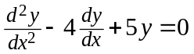 | L2 | CO6 | [2M]
3 | Show that the matrix 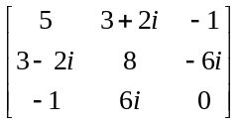is Hermitian. | L2 | CO1 | [2M]
4 | Find the Eigen values of 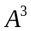, where 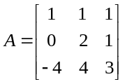 | L1 | CO2 | [2M]
5 | Write the symmetric matrix of the quadratic form 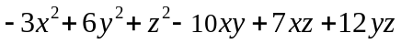 | L2 | CO3 | [2M]
6 | Calculate value where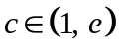, for the functions 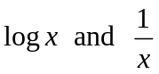 defined in 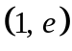 by using Cauchy’s mean value theorem. | L2 | CO4 | [2M]

Part – B Max.Marks: 6x8=48
ANSWER ALL QUESTIONS. EACH QUESTION CARRIES 8 MARKS.

 |  |  | BCLL | CO(s) | Marks
7. | a) | i) Solve the first order non-exact differential equation 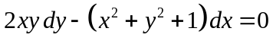  ii) The temperature of cup of milk is 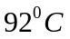 when freshly poured, it is placed in a room of temperature 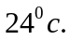 In one minute it was cooled to 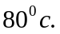 Determine the time at which temperature of cup of milk drops to 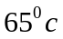. | L3  L3 | CO5  CO5 | [4M]  [4M]
 |  | OR
 | b) | i) Solve the first order linear differential equation 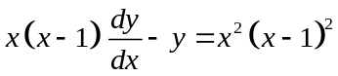  ii) Bacteria in a culture grows exponentially so that initial number has doubled in 3 hours. How many times the initial number will be present after 9 hours ? | L3  L4 | CO5  CO5 | [4M]  [4M]
8. | a) | Solve the second order linear differential equation 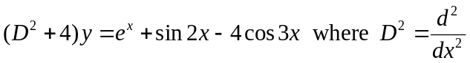 | L3 | CO6 | [8M]
 |  | OR
 | b) | Make use the method of variation of parameters to solve the linear differential equation 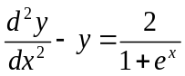 | L4 | CO6 | [8M]
9. | a) | - Apply Gauss Jordan method to find the inverse of the matrix 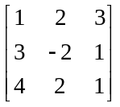  - Determine the rank of the matrix 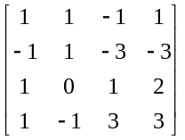by reducing the matrix to Echelon form. | L3  L3 | CO1  CO1 | [4M]  [4M]
 |  | OR
 | b) | Solve the system of non-homogeneous linear equations  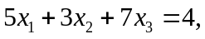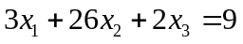 and 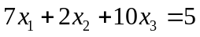 | L3 | CO1 | [8M]
10. | a) | - Apply Cayley-Hamilton theorem to find 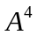 of the matrix 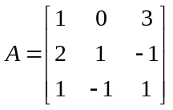  - Show that the matrix 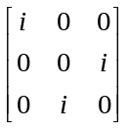 is unitary. | L3  L2 | CO2  CO2 | [5M]  [3M]
 |  | OR
 | b) | Reduce the matrix 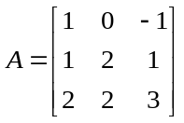 to diagonal form by using modal matrix of A | L3 | CO2 | [8M]
11. | a) | - Discuss the rank and nature of the  Quadratic form 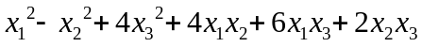  using Eigen values of the matrix of quadratic form.  - Reduce the quadratic form  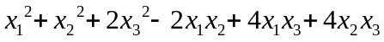 to sum of the squares  form by applying Lagrange’s reduction. | L2  L3 | CO3  CO3 | [4M]  [4M]
 |  | OR
 | b) | By applying orthogonal transformation, reduce the quadratic form 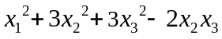 to canonical form and also find rank, index and nature of the quadratic form. | L4 | CO3 | [8M]
12. | a) | - Verify Rolle’s theorem for the function 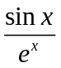 in 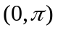  - Write the series expansion of 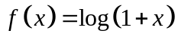 in powers of . | L3  L2 | CO4  CO4 | [4M]  [4M]
 |  | OR
 | b) | Apply Lagrange’s mean value theorem to prove that 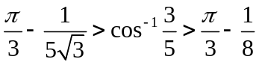. | L3 | CO4 | [8M]

-- 00 -- 00 –

